**Creating a Node-Red UI to view data in Separate Graphical form**

|  |  |
| --- | --- |
|  |  |
| Team ID | PNT2022TMID28961 |
| Project Name | Project - Gas Leakage Monitoring and Alerting  System for Industries. |

After creating the Node Red Web Application, we have to install the UI interface in Node Red.

* Copy and pasting the URL of the NodeRed in the new tab

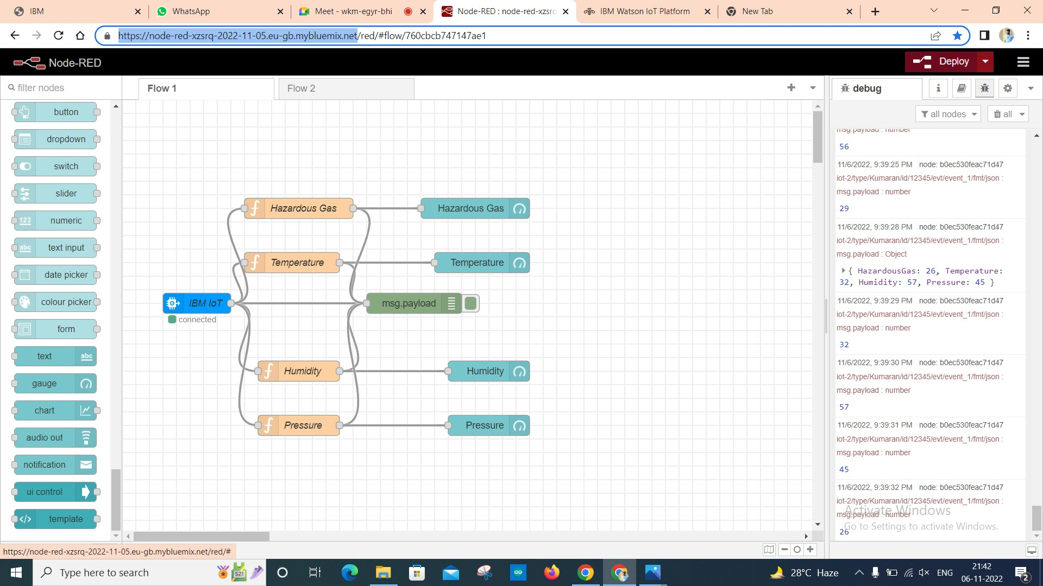

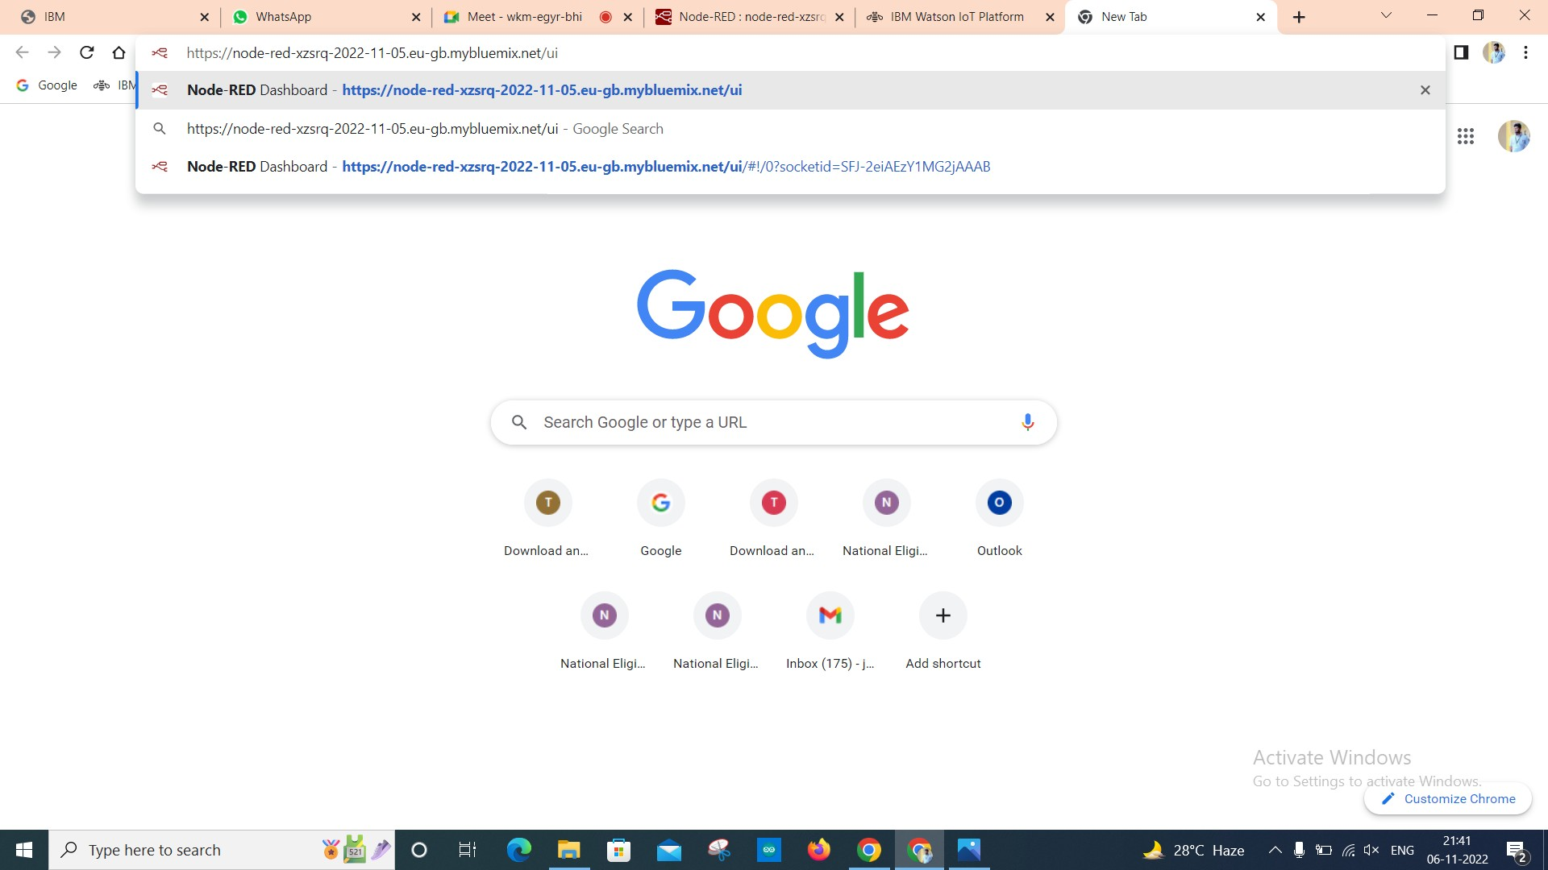

* Output

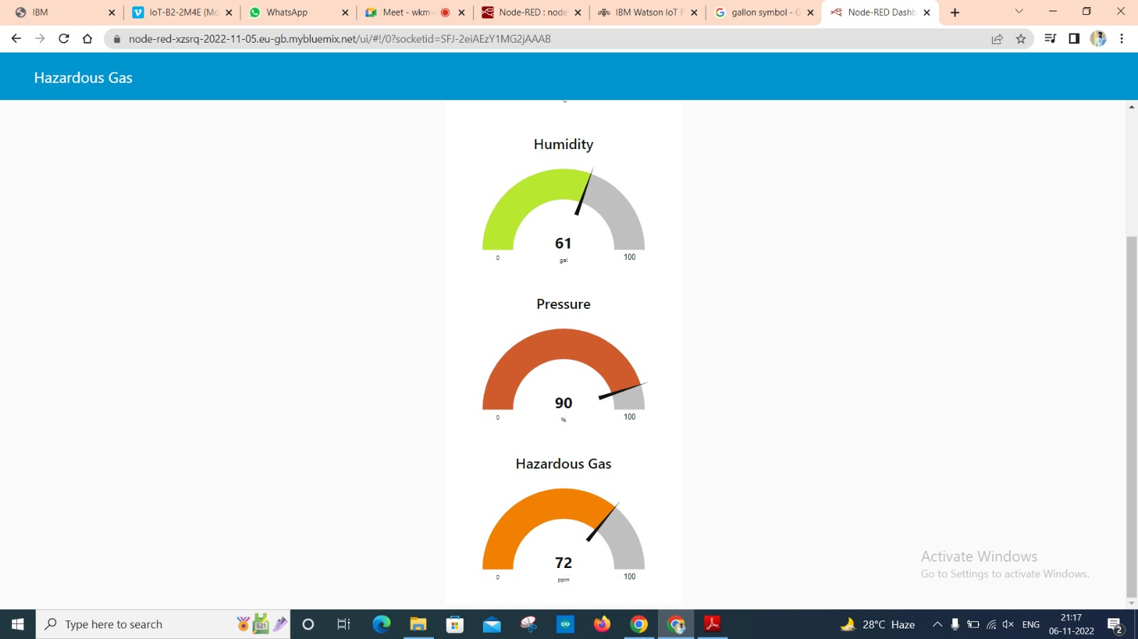

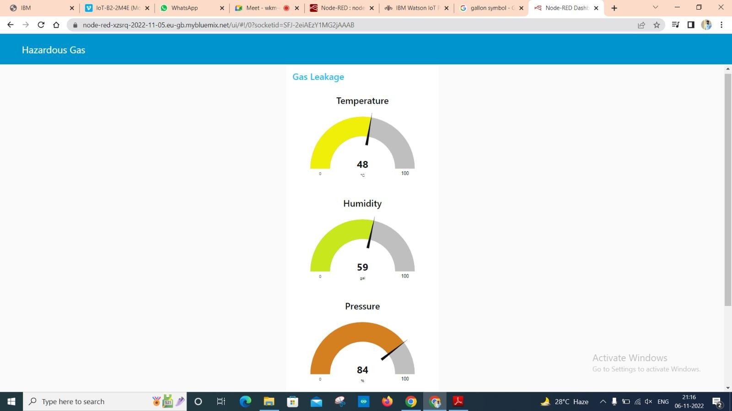

Link: https://node-red-xzsrq-2022-11-05.eu-gb.mybluemix.net/ui/#!/0?socketid=SFJ-2eiAEzY1MG2jAAAB

**Result:**

Thus, the Node Red UI is created successfully.